Project Design Phase-II
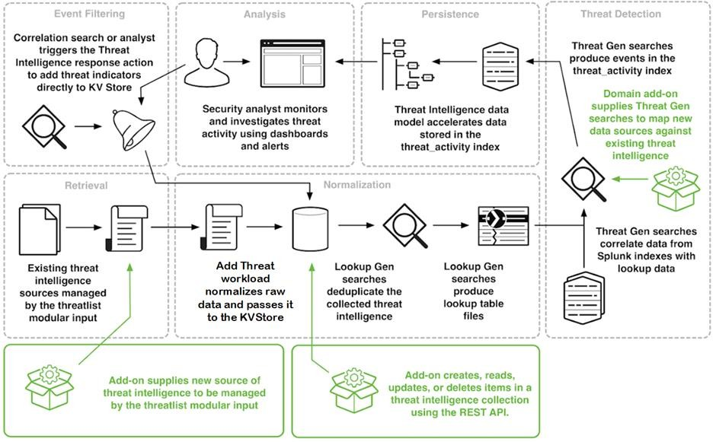
Technology Stack (Architecture & Stack)
Project Name | AI-based Threat Intelligence Platform
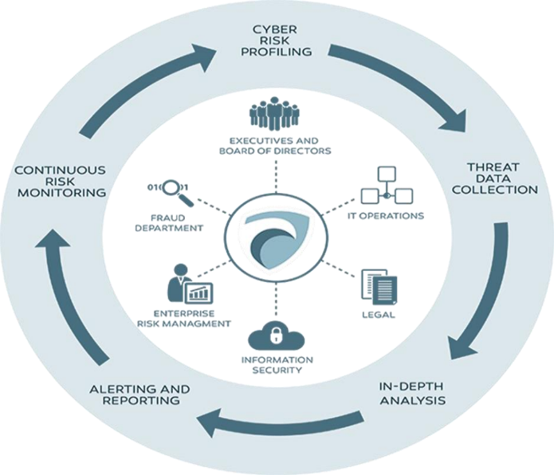

Table 1: Components & Technologies:
S.No | Component | Description | Technology
1 | Threat Detection | Real-time identification of potential threats | Machine Learning, AI
2 | User Interface | Intuitive and user-friendly platform | Web-based, UI/UX Design
3 | Data Integration | Seamless incorporation of diverse data sources| | API Integration
4 | Automated Response | Swift initiation of predefined security protocols | Scripting, Automation
5 | Predictive Analytics | Forecasting potential future threats | Data Analysis, Machine Learning
6 | Reporting and Alerts | Customizable reporting and alerting mechanisms | Data Visualization, Alerts
7 | Compliance Management | Adherence to regulatory standards | Compliance Tools, Monitoring
8 | Scalability | Adaptable architecture for diverse infrastructures | Cloud Computing, Scalable Technologies
9 | Continuous Learning | Feedback loop for continuous improvement | Neural Networks, Data Analysis

Table 2: Application Characteristics:
S.No | Characteristics | Description | Technology
1 | Real-Time Monitoring | Continuous monitoring for immediate threat detection | AI Algorithms, Data Streaming
2 | Predictive Analysis | Forecasting potential future threats | Machine Learning, Data Analytics
3 | Seamless Integration | Smooth integration with diverse security systems | API Integration, Compatibility Solutions
4 | User-Friendly Interface | Intuitive and easy-to-navigate platform | UI/UX Design, Web Technologies
5 | Automated Response | Swift initiation of predefined security protocols | Scripting, Automation Tools
6 | Customizable Reporting | Tailored reporting and alerting mechanisms | Data Visualization Tools, Alert Systems

